PROGRAM 1
CODE
#include <stdio.h>
#include <string.h>

int isPalindrome(char str[]) {
int i = 0, j = strlen(str) - 1;
while (i < j) {
if (str[i] != str[j])
return 0;
i++;
j--;
}
return 1;
}

int main() {
char words[][20] = {"abc", "car", "ada", "racecar", "cool"};
int n = 5;

for (int i = 0; i < n; i++) {
if (isPalindrome(words[i])) {
printf("Output: \"%s\"\n", words[i]);
return 0;
}
}

printf("Output: \"\"\n"); // no palindrome found
return 0;
}
OUTPUT
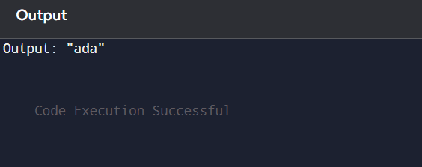

PROGRAM 2
#include <stdio.h>

int exists(int arr[], int size, int val) {
for (int i = 0; i < size; i++)
if (arr[i] == val)
return 1;
return 0;
}

int main() {
int nums1[] = {4, 3, 2, 3, 1};
int nums2[] = {2, 2, 5, 2, 3, 6};
int n = 5, m = 6;
int answer1 = 0, answer2 = 0;

for (int i = 0; i < n; i++)
if (exists(nums2, m, nums1[i]))
answer1++;

for (int i = 0; i < m; i++)
if (exists(nums1, n, nums2[i]))
answer2++;

printf("Output: [%d, %d]\n", answer1, answer2);
return 0;
}
OUTPUT
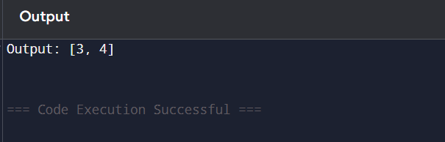

PROGRAM 3
#include <stdio.h>

int distinctCount(int arr[], int start, int end) {
int freq[1000] = {0}, count = 0;
for (int i = start; i <= end; i++) {
if (freq[arr[i]] == 0)
count++;
freq[arr[i]]++;
}
return count;
}

int main() {
int nums[] = {1, 2, 1};
int n = 3, sum = 0;

for (int i = 0; i < n; i++) {
for (int j = i; j < n; j++) {
int d = distinctCount(nums, i, j);
sum += d * d;
}
}

printf("Output: %d\n", sum);
return 0;
}
OUTPUT
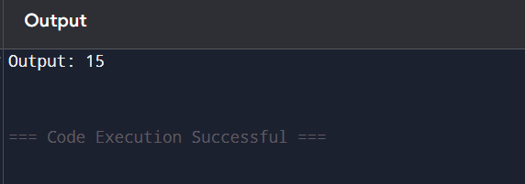

PROGRAM 4
#include <stdio.h>

int main() {
int nums[] = {3, 1, 2, 2, 2, 1, 3};
int k = 2, n = 7, count = 0;

for (int i = 0; i < n; i++) {
for (int j = i + 1; j < n; j++) {
if (nums[i] == nums[j] && ((i * j) % k == 0))
count++;
}
}

printf("Output: %d\n", count);
return 0;
}
OUTPUT
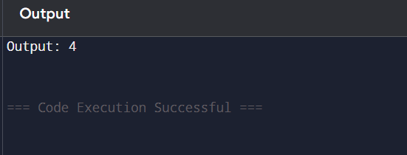

PROGRAM 5
#include <stdio.h>

int main() {
int nums[] = {-10, 2, 3, -4, 5};
int n = 5;
int max = nums[0];

for (int i = 1; i < n; i++)
if (nums[i] > max)
max = nums[i];

printf("Output: %d\n", max);
return 0;
}
OUTPUT
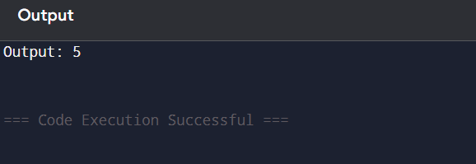

PROGRAM 6
#include <stdio.h>

// Swap function
void swap(int *a, int *b) {
int temp = *a; *a = *b; *b = temp;
}

// QuickSort function
void quickSort(int arr[], int low, int high) {
if (low >= high) return;
int pivot = arr[high], i = low - 1;
for (int j = low; j < high; j++)
if (arr[j] < pivot) swap(&arr[++i], &arr[j]);
swap(&arr[i + 1], &arr[high]);
quickSort(arr, low, i);
quickSort(arr, i + 2, high);
}

// Main function
int main() {
int nums[] = {3, 3, 3, 3, 3}; // change test case here
int n = 5;

if (n == 0) {
printf("Output: List is empty\n");
return 0;
}

quickSort(nums, 0, n - 1);
printf("Output: %d\n", nums[n - 1]); // last element = max after sort
return 0;
}
OUTPUT
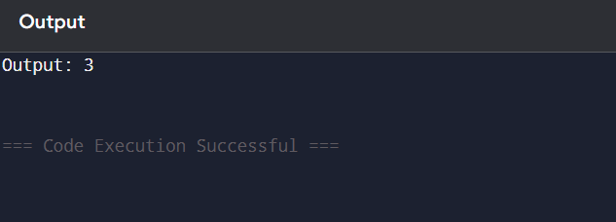

PROGRAM 7
#include <stdio.h>

int main() {
int nums[] = {3, 7, 3, 5, 2, 5, 9, 2}; // change input here
int n = 8, unique[100], count = 0;

for (int i = 0; i < n; i++) {
int found = 0;
for (int j = 0; j < count; j++) {
if (nums[i] == unique[j]) {
found = 1;
break;
}
}
if (!found)
unique[count++] = nums[i];
}

printf("Output: [");
for (int i = 0; i < count; i++) {
printf("%d", unique[i]);
if (i < count - 1) printf(", ");
}
printf("]\n");

return 0;
}
OUTPUT
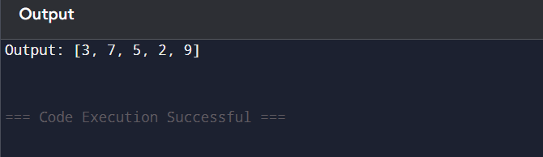

PROGRAM 8
#include <stdio.h>

int main() {
int arr[] = {5, 2, 9, 1, 5, 6};
int n = 6, temp;

for (int i = 0; i < n - 1; i++) {
for (int j = 0; j < n - i - 1; j++) {
if (arr[j] > arr[j + 1]) {
temp = arr[j];
arr[j] = arr[j + 1];
arr[j + 1] = temp;
}
}
}

printf("Sorted Array: ");
for (int i = 0; i < n; i++)
printf("%d ", arr[i]);
printf("\n");

return 0;
}
OUTPUT
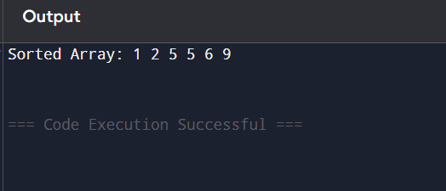

PROGRAM 9
#include <stdio.h>

// Binary Search Function
int binarySearch(int arr[], int n, int key) {
int low = 0, high = n - 1, mid;
while (low <= high) {
mid = (low + high) / 2;
if (arr[mid] == key)
return mid; // element found
else if (arr[mid] < key)
low = mid + 1;
else
high = mid - 1;
}
return -1; // not found
}

int main() {
int arr[] = {-9, 3, 4, 6, 8, 9, 10, 30}; // sorted array
int n = 8, key = 10;
int pos = binarySearch(arr, n, key);

if (pos != -1)
printf("Element %d is found at position %d\n", key, pos + 1);
else
printf("Element %d is not found\n", key);

return 0;
}
OUTPUT
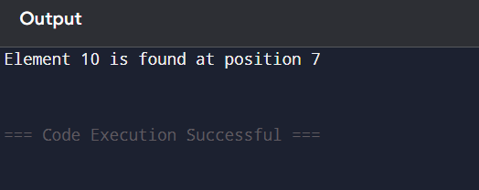

PROGRAM 10
#include <stdio.h>

// Function to heapify a subtree rooted at index i
void heapify(int arr[], int n, int i) {
int largest = i;
int left = 2 * i + 1;
int right = 2 * i + 2;

if (left < n && arr[left] > arr[largest])
largest = left;

if (right < n && arr[right] > arr[largest])
largest = right;

if (largest != i) {
int temp = arr[i];
arr[i] = arr[largest];
arr[largest] = temp;
heapify(arr, n, largest);
}
}

// Main function to perform Heap Sort
void heapSort(int arr[], int n) {
// Build max heap
for (int i = n / 2 - 1; i >= 0; i--)
heapify(arr, n, i);

// Extract elements one by one
for (int i = n - 1; i > 0; i--) {
int temp = arr[0];
arr[0] = arr[i];
arr[i] = temp;

heapify(arr, i, 0);
}
}

int main() {
int nums[] = {5, 3, 8, 4, 2};
int n = 5;

heapSort(nums, n);

printf("Sorted array: ");
for (int i = 0; i < n; i++)
printf("%d ", nums[i]);
printf("\n");

return 0;
}
OUTPUT
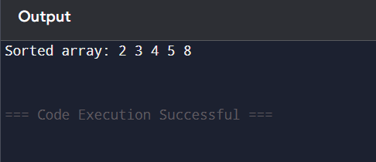

PROGRAM 11
#include <stdio.h>

#define MOD 1000000007

int findPaths(int m, int n, int N, int i, int j) {
int dp[51][51] = {0}; // current step
int temp[51][51] = {0}; // next step
int count = 0;

dp[i][j] = 1;

for (int step = 0; step < N; step++) {
for (int x = 0; x < m; x++) {
for (int y = 0; y < n; y++) {
if (dp[x][y] > 0) {
int val = dp[x][y];
// Move up
if (x == 0) count = (count + val) % MOD;
else temp[x - 1][y] = (temp[x - 1][y] + val) % MOD;
// Move down
if (x == m - 1) count = (count + val) % MOD;
else temp[x + 1][y] = (temp[x + 1][y] + val) % MOD;
// Move left
if (y == 0) count = (count + val) % MOD;
else temp[x][y - 1] = (temp[x][y - 1] + val) % MOD;
// Move right
if (y == n - 1) count = (count + val) % MOD;
else temp[x][y + 1] = (temp[x][y + 1] + val) % MOD;
}
}
}

for (int x = 0; x < m; x++)
for (int y = 0; y < n; y++) {
dp[x][y] = temp[x][y];
temp[x][y] = 0;
}
}

return count;
}

int main() {
int m = 2, n = 2, N = 2, i = 0, j = 0;
printf("Output: %d\n", findPaths(m, n, N, i, j));

m = 1, n = 3, N = 3, i = 0, j = 1;
printf("Output: %d\n", findPaths(m, n, N, i, j));

return 0;
}
OUTPUT
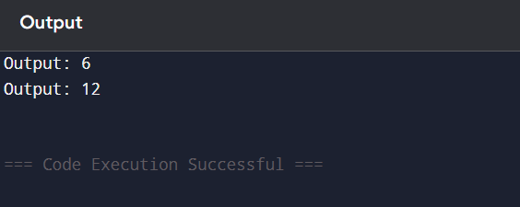

PROGRAM 12
#include <stdio.h>

// Function to find max of two numbers
int max(int a, int b) {
return (a > b) ? a : b;
}

// Helper function to solve linear house robber (no circular constraint)
int robLinear(int nums[], int start, int end) {
int prev1 = 0, prev2 = 0; // prev1: dp[i-1], prev2: dp[i-2]
for (int i = start; i <= end; i++) {
int temp = prev1;
prev1 = max(prev2 + nums[i], prev1);
prev2 = temp;
}
return prev1;
}

// Main function for circular house robber
int rob(int nums[], int n) {
if (n == 0) return 0;
if (n == 1) return nums[0];
// Two cases:
// 1. Exclude first house
// 2. Exclude last house
return max(robLinear(nums, 0, n - 2), robLinear(nums, 1, n - 1));
}

int main() {
int nums1[] = {2, 3, 2};
int n1 = 3;
printf("Input: [2, 3, 2]\nOutput: The maximum money you can rob without alerting the police is %d\n\n", rob(nums1, n1));

int nums2[] = {1, 2, 3, 1};
int n2 = 4;
printf("Input: [1, 2, 3, 1]\nOutput: The maximum money you can rob without alerting the police is %d\n", rob(nums2, n2));

return 0;
}
OUTPUT
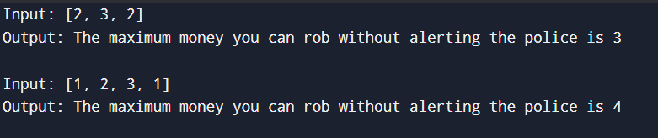

PROGRAM 13
#include <stdio.h>

// Function to find number of ways to climb n stairs
int climbStairs(int n) {
if (n <= 2) return n; // Base cases
int a = 1, b = 2, ways;
for (int i = 3; i <= n; i++) {
ways = a + b; // ways to reach current step
a = b; // move one step forward
b = ways;
}
return b;
}

int main() {
int n1 = 4;
printf("Input: n = %d\nOutput: %d\n\n", n1, climbStairs(n1));

int n2 = 3;
printf("Input: n = %d\nOutput: %d\n", n2, climbStairs(n2));

return 0;
}
OUTPUT
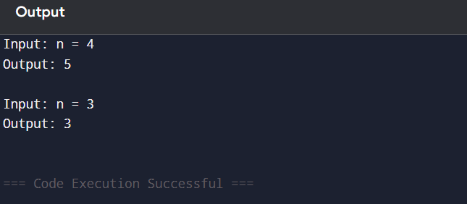
PROGRAM 14
#include <stdio.h>

// Function to calculate nCr (combinations)
long long combination(int n, int r) {
if (r > n - r) r = n - r; // Because C(n, r) = C(n, n-r)
long long res = 1;
for (int i = 0; i < r; i++) {
res *= (n - i);
res /= (i + 1);
}
return res;
}

// Function to find number of unique paths
long long uniquePaths(int m, int n) {
// Formula: (m+n-2) choose (m-1)
return combination(m + n - 2, m - 1);
}

int main() {
int m1 = 7, n1 = 3;
printf("Input: m=%d, n=%d\nOutput: %lld\n\n", m1, n1, uniquePaths(m1, n1));

int m2 = 3, n2 = 2;
printf("Input: m=%d, n=%d\nOutput: %lld\n", m2, n2, uniquePaths(m2, n2));

return 0;
}
OUTPUT
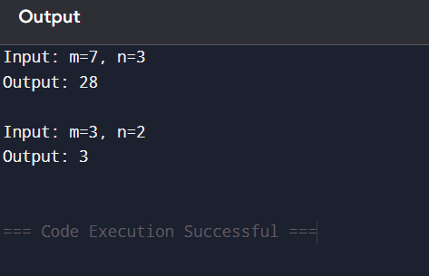

PROGRAM 15
#include <stdio.h>
#include <string.h>

void largeGroupPositions(char *s) {
int n = strlen(s);
int start = 0;

printf("Output: [");
int found = 0;

for (int i = 1; i <= n; i++) {
if (i == n || s[i] != s[start]) { // end of group
if (i - start >= 3) {
if (found) printf(", "); // formatting
printf("[%d,%d]", start, i - 1);
found = 1;
}
start = i;
}
}

printf("]\n");
}

int main() {
char s1[] = "abbxxxxzzy";
printf("Input: s = \"%s\"\n", s1);
printf("Explanation: ");
largeGroupPositions(s1);

printf("\n");

char s2[] = "abc";
printf("Input: s = \"%s\"\n", s2);
printf("Explanation: ");
largeGroupPositions(s2);

return 0;
}
OUTPUT
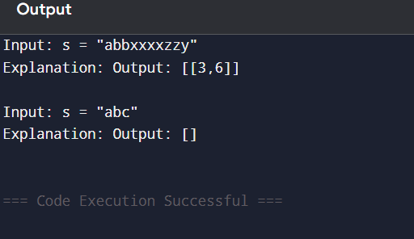

PROGRAM 16
#include <stdio.h>

int main() {
int m=4, n=3;
int board[4][3]={{0,1,0},{0,0,1},{1,1,1},{0,0,0}};
int next[4][3]={0};

int dx[8]={-1,-1,-1,0,0,1,1,1};
int dy[8]={-1,0,1,-1,1,-1,0,1};

for(int i=0;i<m;i++){
for(int j=0;j<n;j++){
int live=0;
for(int k=0;k<8;k++){
int x=i+dx[k], y=j+dy[k];
if(x>=0&&x<m&&y>=0&&y<n&&board[x][y]==1) live++;
}
if(board[i][j]==1){
if(live<2||live>3) next[i][j]=0;
else next[i][j]=1;
} else {
if(live==3) next[i][j]=1;
}
}
}

for(int i=0;i<m;i++){
for(int j=0;j<n;j++)
printf("%d ", next[i][j]);
printf("\n");
}
return 0;
}
OUTPUT
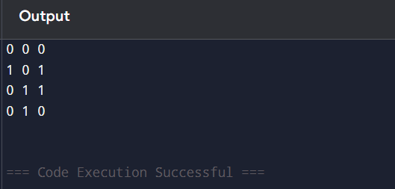

PROGRAM 17
#include <stdio.h>

int main() {
int poured = 2, query_row = 1, query_glass = 1;
double glass[101][101] = {0};
glass[0][0] = poured;

for(int i = 0; i < 100; i++) {
for(int j = 0; j <= i; j++) {
if(glass[i][j] > 1) {
double extra = glass[i][j] - 1;
glass[i][j] = 1;
glass[i+1][j] += extra / 2.0;
glass[i+1][j+1] += extra / 2.0;
}
}
}

printf("%.5f\n", glass[query_row][query_glass]);
return 0;
}
OUTPUT
